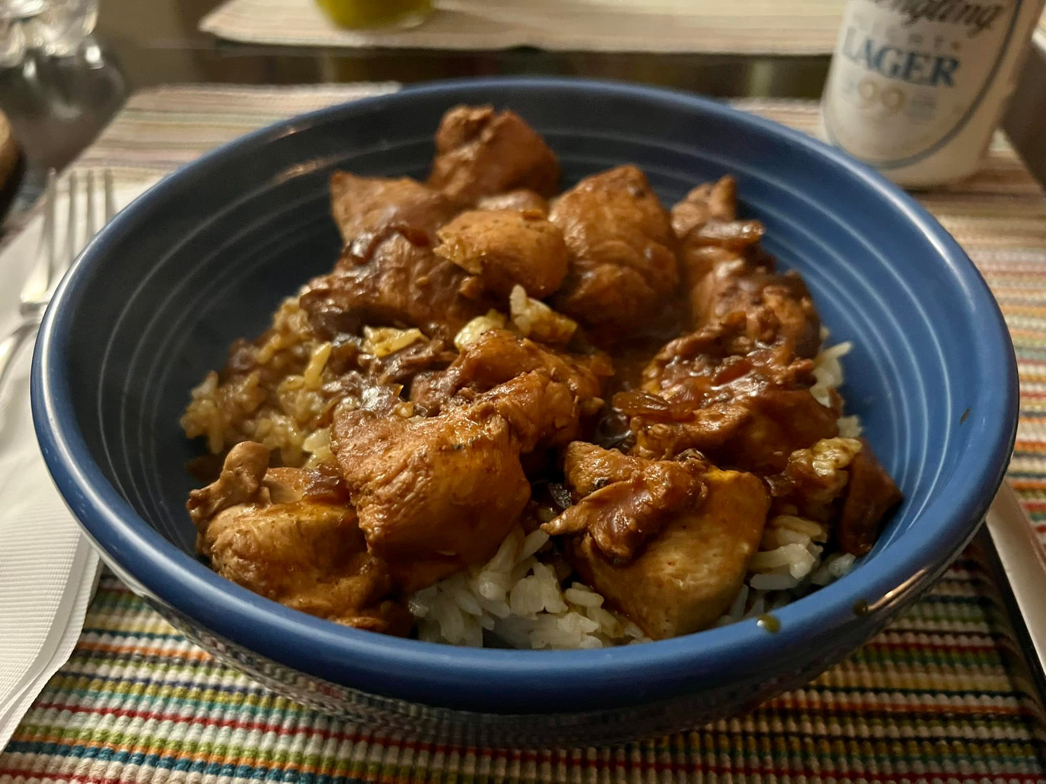

Soy and Sriracha Chicken

Serves 4 | Preparation Time 15 minutes | Cooking Time 25 minutes

Preparation:

Cut five chicken breasts into inch-size cubes. Cover the chicken with three tablespoons of corn starch in a plastic container with a lid. Finely chop half an onion, and top the chicken with it. Season with pepper, salt, garlic powder, chopped garlic, and chili powder to your satisfaction. Add chopped pickled jalapenos for extra heat (optional.) Add one cup of light soy sauce, four tablespoons (or more per heat preference) of Sriracha, and four tablespoons of olive oil. Close lid, shake vigorously. Marinate for two to four hours.

Rice:

Bring two large mugs of water to boil, add a dash of coconut oil, two teaspoons of chicken broth powder, and half a teaspoon of Harissa (optional.) Turn heat to low, add one large mug of jasmine rice and simmer on low heat for 17 minutes. Stir occasionally. Set aside, stir with a fork once more.

Chicken:

As the rice simmers, put a lidded pan with a spray of PAM on high heat. When hot, add the chicken and brown for a few minutes, stirring occasionally. Add 1 pint of red or white wine (per preference) and simmer at low to medium heat for 25 minutes or until the chicken is done.

Serve chicken over rice in a bowl with an (optional) side of chopped salad. Enjoy the leftovers.

